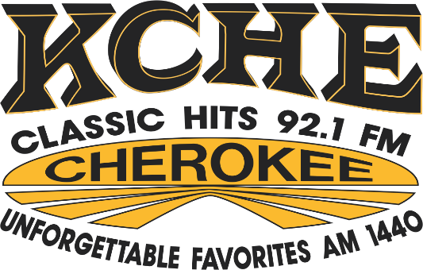
DIGITAL ADVERTISING
ONLINE AT
KCHERADIO.COM

Available Website Zone | Banner Size | Exclusive Monthly | Rotation Monthly
Header Leaderboard | IAB Rectangle (728x90) | $75 | $50
Left Column Badge 1 | Custom (350x250) | $100 | $75
Left Column Badge 2 | Custom (350x250) | $100 | $75
Footer Leaderboard | IAB Rectangle (728x90) | $100 | $50
Footer Ad 1 | IAB Rectangle (180x150) | $50 | $25
Footer Ad 2 | IAB Rectangle (180x150) | $50 | $25
Footer Ad 3 | IAB Rectangle (180x150) | $50 | $25
Footer Ad 4 | IAB Rectangle (180x150) | $50 | $25
Footer Ad 5 | IAB Rectangle (180x150) | $50 | $25
Footer Ad 6 | IAB Rectangle (180x150) | $50 | $25
Footer Ad 7 | IAB Rectangle (180x150) | $50 | $25
Footer Ad 8 | IAB Rectangle (180x150) | $50 | $25
Footer Ad 9 | IAB Rectangle (180x150) | $50 | $25
Footer Ad 10 | IAB Rectangle (180x150) | $50 | $25
Mobile Ad Unit | Custom (320x50) | $75 | $50

201 S 5th Street, Cherokee, IA
Phone: (712) 225-2511
KCHERADIO.COM

